


FINANCIAL ANALYST TEAM
(150)

NATIONAL – 2020

PRELIMINARY

TOTAL POINTS ___________ (170)

Failure to adhere to any of the following rules will result in disqualification:
- Contestant must hand in this test booklet and all printouts. Failure to do so will result in disqualification.
- No equipment, supplies, or materials other than those specified for this event are allowed in the testing area. No previous BPA tests and/or sample tests or facsimile (handwritten, photocopied, or keyed) are allowed in the testing area.
- Electronic devices will be monitored according to ACT standards.

Property of Business Professionals of America.
May be reproduced only for use in the Business Professionals of America
Workplace Skills Assessment Program competition.

Description
The team will use strategic planning and problem-solving skills to provide solutions to the business case study provided. At State and National level, teams will be presented with an additional element to the scenario that requires revision of their final presentation.

Modification at National Prelims Competition

Lynn purchases most of her inventory from a supplier based out of China. The latest numbers indicate that the cost of inventory will increase by 3%-5% over the next few years.

Initial Case Study Topic:
Lynn’s Kids first opened in 1998 as a single-store children’s clothing boutique in Northampton, Massachusetts. Over the past 22 years, Lynn’s Kids has incorporated into a small, private corporation, and expanded to Westborough in 2001 and Boston in 2014.

While sales have remained steady since opening their most recent store, profits have fallen in recent years, and Lynn is concerned that she might have to close her business. Lynn’s long-time bookkeeper, Scott, has compiled her financial data for the last five years. Lynn took out a mortgage to buy her first store in 1988, but her other two stores are leased. Lease payments make up 30% of the total operating expenses, with the lease on the Boston location comprising 80% of the total lease payments. Each store has one full-time manager, who makes $50,000 a year, and the rest of the employees are part-time. The part-time wages constitute a total of 20% of the operating expenses, with the Boston store using 50% of the wages and the other two stores being even. Lynn pays herself a salary of $100,000 for being the CEO, but she is considering reducing that amount if it means she can save her business. Two years ago Lynn increased her advertising expenses to $80,000 to try to increase sales, with the 70% of her advertising efforts being focused on the Boston store (20% of advertising is spent on the Westborough store and the remainder on the Northampton store). The remainder of the operating expenses are used to cover insurance, utilities, and other miscellaneous items (these expenses are split in a 30/30/40 split between the 3 stores, with Boston having the highest insurance rate).

Lynn took out a ten-year note to open to Boston store, and she’s concerned that sales have not grown enough to cover the loan payments. Lynn has resorted to using the line of credit from her bank to help pay the bills. Between the three stores, the original store in Northampton continues to have the most sales, comprising 42% of the total sales. The Westborough store has the lowest sales, comprising only 28% of the total sales.

Lynn is asking for your advice. She would like to save her business, but isn’t sure if maybe she should close all of her stores, close some of her stores, or start selling her clothes online. Please compile Lynn’s financial statements for the past five years (assume a 30% corporate tax rate), and prepare your analysis and presentation for the Board of Directors of Lynn’s Kids.

A team will be disqualified for violations of the Copyright and Fair Use Guidelines.

Teams who do not submit an entry that follows this topic will be disqualified.

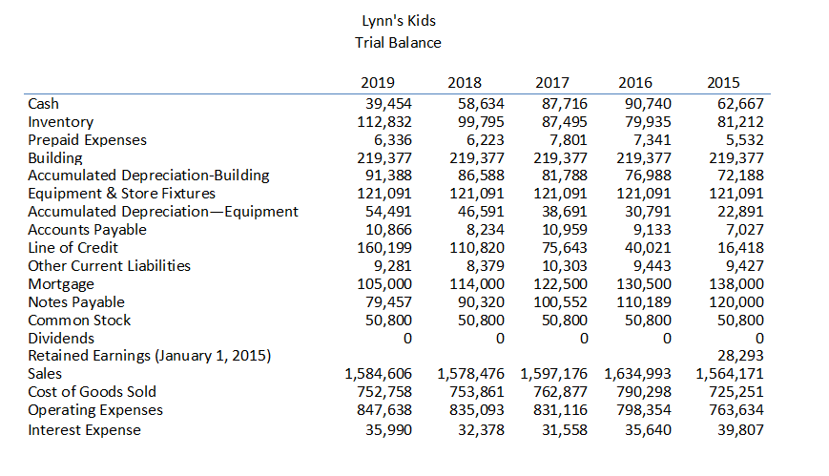

INCOME STATEMENT
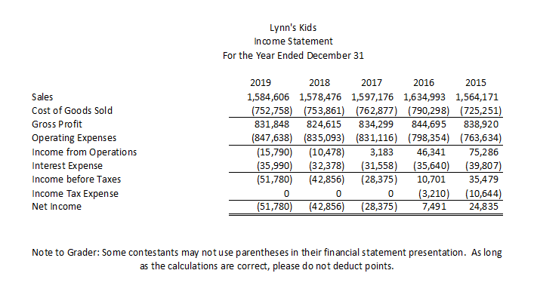

RETAINED EARNINGS
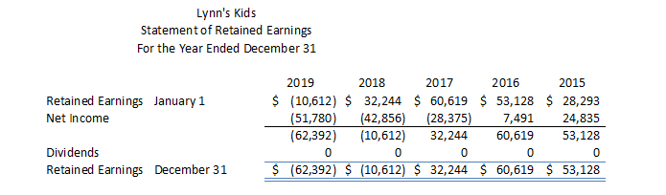

BALANCE SHEET
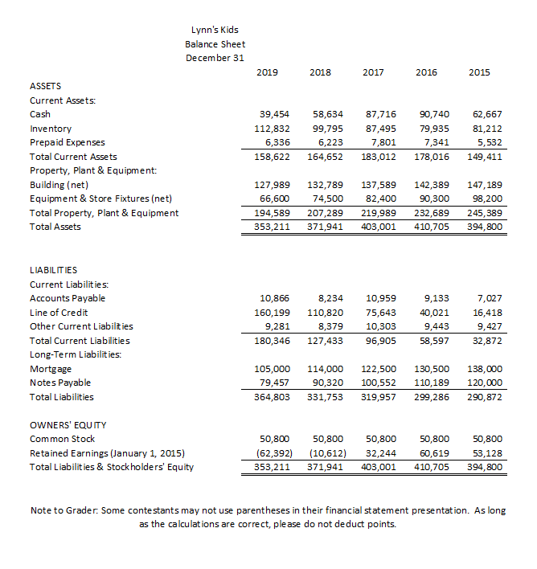

judging procedure
- Teams will be introduced by team number.
- No advisor contact will be allowed between the time of receiving the topic and the delivery of the presentation.
- Cell phones may not be used in the preparation room.
- Teams will present before a panel of judges and timekeeper.
- As a team of judges, formulate two to three questions to ask at the conclusion of the presentation. Be sure to ask the same questions of each team.
- All team members must participate.
- The length of set-up will be no more than three (3) minutes.
- The length of the presentation will be no more than ten (10) minutes; followed by judges’ questions not to exceed ten (10) minutes.
- Excuse teams upon completion of judges’ questions.
- There can be no ties in the top ten (10) teams. It is the responsibility of the judges to break any ties.
- Administrator will fill out ranking sheet prior to dismissing the judges.
- If more than one (1) section is necessary, finalists will be determined by selecting an equal number from each section.
- Give administrator all Judges’ Rating Sheets, Judge Evaluation Sheets, and contest materials.
- No audience will be allowed.

Please double-check and verify all scores!

